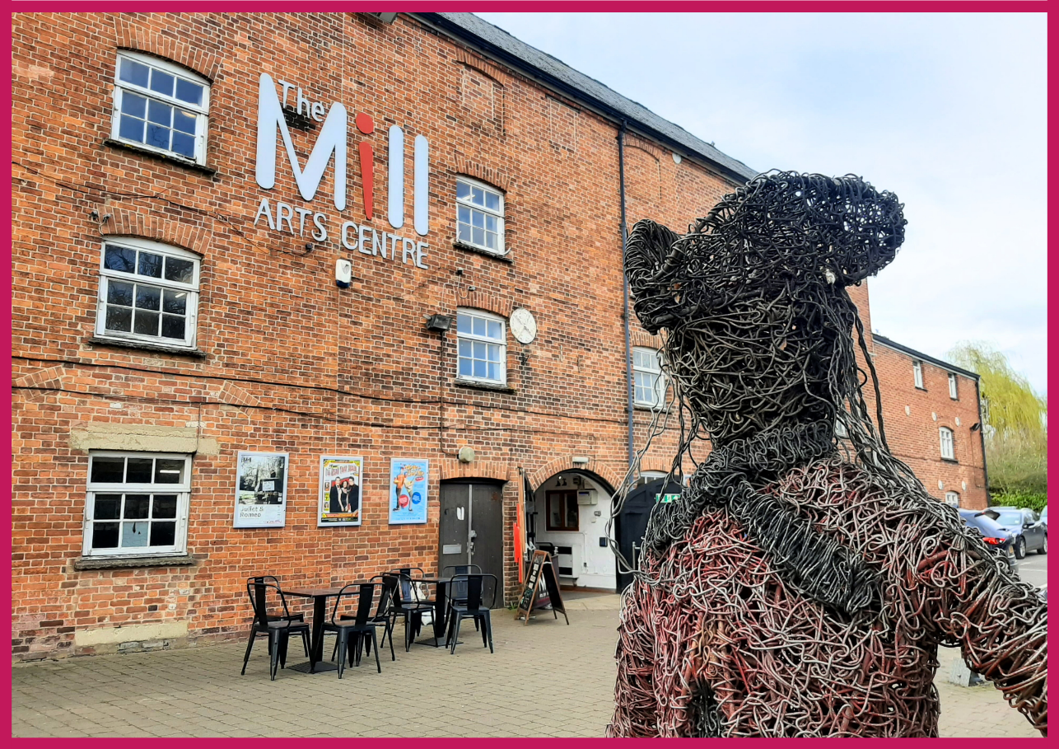
Work Experience Pack
HELLO & WELCOME
Thank you for your interest in our 2024 Work Experience Programme. Our programme offers 14–18-year-olds a hands-on experience that will broaden understanding of the arts and cultural sector and provide valuable insights into the multifaceted operations of The Mill Arts Centre.

Dates and time of each placement will be arranged and agreed between the Creative Learning Officer and the successful applicant.

This pack contains:
- Information about The Mill
- Information about our Work Experience programme
- Health and Safety Information
- How to apply to take part in the Mill’s 2024 Work Experience programme.

If you would like this information in a different format, please contact katy.owen@themillartscentre.co.uk
ABOUT THE MILL

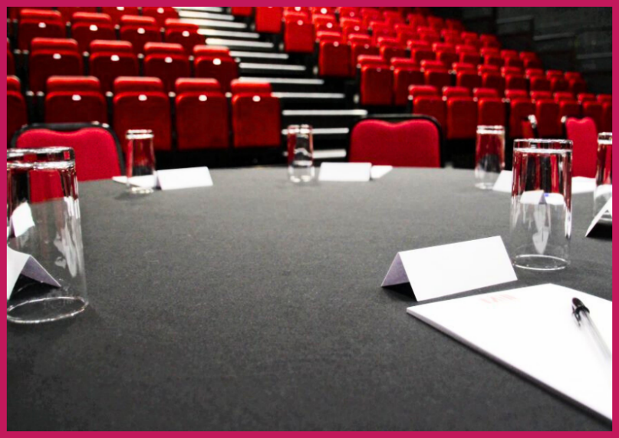
The Mill is a small multi-art form venue with big ambitions. Situated in the North Oxfordshire market town of Banbury, it is the focus of cultural life as the only public arts and performance venue in the Cherwell District.

Our 237-seat theatre plays host to theatre, dance, comedy, and music events which run alongside a packed creative learning and participation programme with a focus on both visual and performing arts.

Increasingly we are working outside of our building and in partnership with a wide range of organisations in Banbury and Bicester to ensure that all in our communities can experience the benefit of seeing and taking part in professionally led creative and cultural activities.

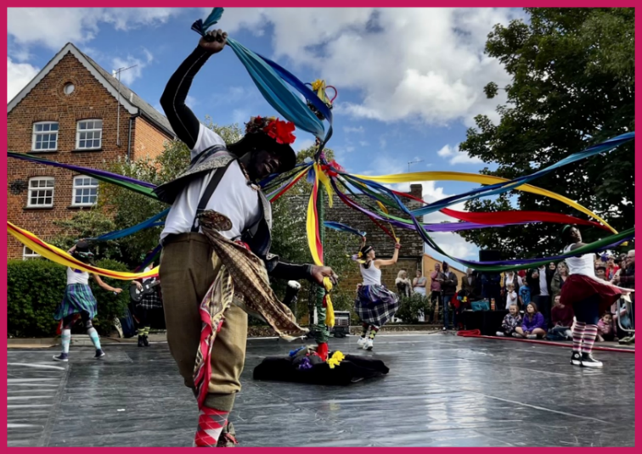
Having recently been successful in our application to become a National Portfolio Organisation for Arts Council England, the successful candidate will join our ambitious team at a hugely exciting time. This is an opportunity to play a key role to support the development of The Mill in line with Arts Council’s Let’s Create strategy and secure its place as the cultural heart of the region for generations to come.

OUR MISSION & VALUES

The Mill aims to be the cultural heart of Banbury and beyond. Proudly celebrating a diverse creative programme of high-quality arts experiences; telling stories that encourage everyone in our communities to learn and take part; to have fun and be inspired.

We want to be an exemplar, vibrant, indispensable Arts Centre of which Banbury is rightly proud; relevant to the whole community through a diverse programme which celebrates both taking part in and seeing first class arts and entertainment experiences.

We are much more than just a building, we will work throughout the region to support artists to create and present the highest quality arts experiences.

Our core values are:
- Heart and Trust
- For All
- Quality
- Creativity
- Bold and Forward Thinking

To achieve our aims, we offer three strands of work:
- Live events and film screenings including theatre, dance, music and comedy.
- Participatory workshops, events and experiences including performing arts, visual arts and craft and holistic wellbeing.
- Visual art exhibitions.

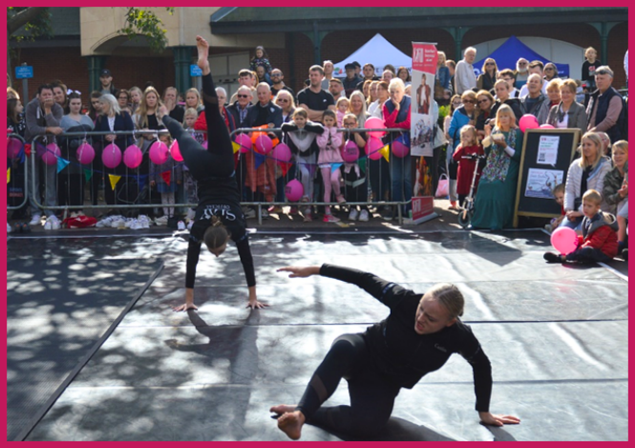
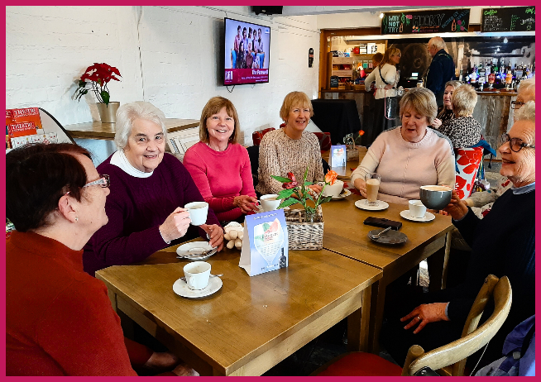

ABOUT THE 2024 WORK EXPERIENCE PROGRAMME

Post: Work Experience Student
Reporting to: Creative Learning Officer
Salary: This is an unsalaried opportunity.
Place of work: The Mill Arts Centre, with the opportunity to work across our off-site programme in other locations (please note this is not a requirement)
Hours of Work: Dates and time of each placement will be arranged and agreed between the Creative Learning Officer and the successful applicant. Some activities may take place during evenings and weekends due to the nature of the business.

Our comprehensive work experience programme offers a diverse array of engaging activities across the following departments:

- Programming & Marketing
- Operations/Front of House
- Technical Operations
- Creative Learning
- Community Engagement
- Arts Administration

Potential activities may include:

- Assisting with exhibition installation
- Designing marketing plans
- Distributing promotional materials
- Taking meeting minutes
- Assisting with room hires and functions
- Ushering for live performance
- Developing social media content

HEALTH & SAFETY
All work experience students will be inducted to The Mill’s health and safety policies and procedures. All work experience students will be expected to follow all health and safety procedures and any actions demonstrated by our health and safety committee.

The Mill Arts Centre will be able to provide DBS numbers for our staff and information about our Designated Safeguarding Leaders.

Due to the historic nature of the building, we regrettably are unable to facilitate wheelchair users above the ground floor.

HOW TO APPLY
Please apply by sending the following to Laura Walker (laura.walker@themillartscentre.co.uk) by 12pm (midday) on Sunday 4th February 2024.

- a completed application form

If you have any questions or require assistance, please contact laura.walker@themillartscentre.co.uk.

Good luck!

