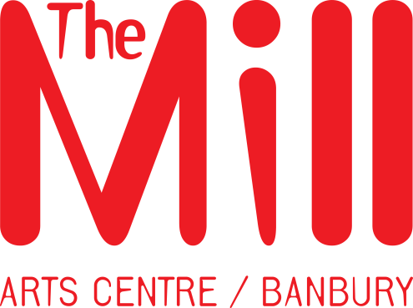

Marketing and Development Officer
PERSON SPECIFICATION

Skills and Experience

- A genuine commitment to broadening access to the arts for all, respecting all of our communities and their needs
- Passion for the arts and the vision of The Mill Arts Centre
- At least two years’ experience in a marketing role
- At least two years’ experience in a development role (voluntary or paid)
- Good knowledge of marketing and communication tools, which can be implemented to develop arts audiences
- Extensive experience in the practical application of digital communications and website maintenance and development
- Excellent written and verbal communication skills and presentation skills
- Excellent attention to detail
- High level of ability to prioritise and manage multiple projects
- High level of ability to analyse and interpret statistical information
- Experience of using Microsoft Word, Excel and PowerPoint, emails, design software, website management software and the internet
- Experience with web based communications and websites
- Experience of event coordination and delivery particularly in relation to fundraising

Qualities

- Collaborative approach to team working with a positive and forward thinking attitude to the wellbeing of the organisation and individual team members
- Understanding and commitment to equal opportunities/diversity in all aspects of service delivery and relationships with colleagues displaying a respectful attitude at all times
- Ability to work effectively with a wide range of people and organisations , building positive relationships
- Creative and imaginative approach to marketing and promoting an arts venue/programme
- Enthusiastic and proactive approach to work, with an ability to work under pressure

