**Candidate Pack**

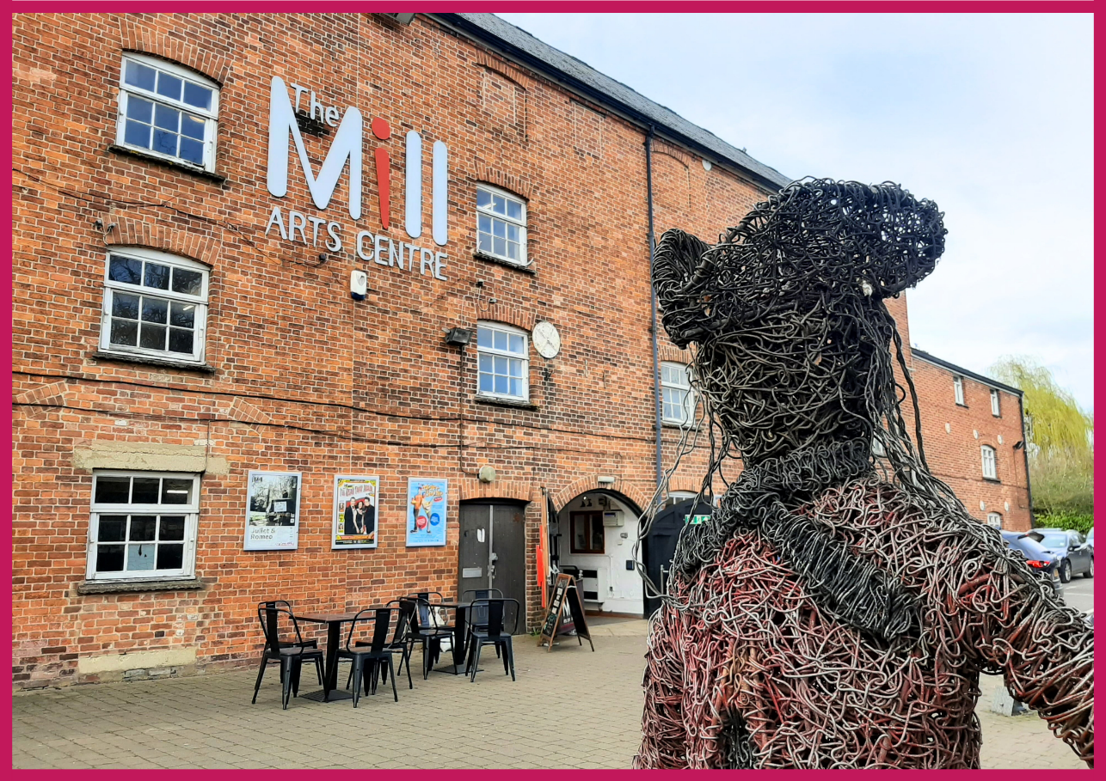

**HELLO & WELCOME**

Thank you for your interest in this role. It’s an exciting time to join The Mill Arts Centre, as we are now in our third year as an Arts Council England National Portfolio Organisation (NPO).

Our Customer Service Assistants are responsible for the delivery of efficient and effective Customer Service across both our Box Office and Café Bar, ensuring that The Mill Arts Centre Trust is a welcoming and vibrant space for audiences, customers and artists.

**ABOUT THE MILL**

The Mill is a small multi-art form venue with big ambitions. Situated in the North Oxfordshire market town of Banbury, it is the focus of cultural life as the only public arts and performance venue in the Cherwell District.

Our 237-seat theatre plays host to theatre, dance, comedy and music events which run alongside a packed creative learning and participation programme with a focus on both visual and performing arts.

Increasingly we are working outside of our building and in partnership with a wide range of organisations to ensure that all in our communities can experience the benefit of seeing and taking part in professionally led creative and cultural activities.

Having recently become a National Portfolio Organisation for Arts Council England in 2023, successful candidates will join our ambitious team at a hugely exciting time. This is an opportunity to become part of a team that is passionate in securing The Mill’s place as the cultural heart of the region for generations to come.

## **OUR MISSION & VALUES**

The Mill aims to be the cultural heart of Banbury and beyond. Proudly celebrating a diverse creative programme of high-quality arts experiences; telling stories that encourage everyone in our communities to learn and take part; to have fun and be inspired.

We want to be an exemplar, vibrant, indispensable Arts Centre of which Banbury is rightly proud; relevant to the whole community through a diverse programme which celebrates both taking part in and seeing first class arts and entertainment experiences.

We are much more than just a building; we will work throughout the region to support artists to create and present the highest quality arts experiences.

**Our core values are:**

* Heart and Trust
* For All
* Quality
* Creativity
* Bold and Forward Thinking

**To achieve our aims, we offer three strands of work:**

* Live events including theatre, dance, music, comedy and variety.
* Participatory workshops, events and experiences including performing arts, visual arts and craft and holistic wellbeing.
* Visual art exhibitions.

## **ABOUT THE ROLE**

**Post:**  Customer Service Assistant

**Line Manager:**  Assitant Operations Manager

**Accountable to:** Operations Manager, Assistant Operations Manager, Duty Managers.

**Salary:** £12.21 per hour

**Hours:** 0 Hour contract to include evenings and weekends

**Holiday:** 12.07% of hourly wage per hour worked

**Probation Period:** 3 months

**Place of work:**  The Mill Arts Centre and occasional off-site events

## **KEY AREAS OF RESPONSIBILITY**

**Customer Service**

* Ensure that all public areas provide a warm and welcoming environment by greeting all visitors pleasantly and dealing with their enquiries professionally.
* To assist customers with general enquiries about facilities, activities and events.
* To be familiar with information pertaining to current and future performances and activities and to be proactive in encouraging participation in the programme and facilities offered at The Mill.
* To ensure that visitors with access requirements are catered for appropriately.
* To effectively deal with all customer comments or complaints, escalating them to the Operations Team Management as appropriate.

**Bar**

* To serve behind the bar efficiently and with a helpful and approachable manner.
* To be knowledgeable about the products we stock.
* Endeavour to upsell and promote the charity’s products and visiting companies’ merchandise at every opportunity.
* Maintain stock levels and rotation behind bars and storage areas.
* To prepare and serve food within all food hygiene standards.
* To work with the rest of the customer services team to create a friendly and vibrant atmosphere for our customers.
* To ensure the highest levels of cleanliness behind the bar and in the foyer and gallery space.
* To ensure compliance with all Health and Safety procedures and that licensing law is strictly adhered to.

**Box Office**

* To staff the Box Office and book places for all Mill events and classes ensuring that the processes for ticketing are completed accurately and efficiently.
* Ensure the accurate and efficient updating and maintenance of Box Office data and systems. Operate all systems with a strong emphasis on data protection and privacy protocols.
* To assist with sales, merchandise and promotion activities, including maintaining displays and publicity materials.
* To participate in publicity events and other PR activities as required

**Reception**

* Manage the phone system, answering incoming calls and re-routing calls to the relevant extensions.
* Take and distribute messages and forward emails as appropriate and maintain an efficient internal communications system.
* Sort and distribute outgoing mail as required. Receive and sign for parcels, special delivery items and packages that arrive during the day. Ensure that deliveries are distributed by informing the relevant persons of their arrival.
* Assist with administrative tasks as required.

**Building**

* Maintain good housekeeping in all public areas.
* To be familiar with the security and fire alarm systems and ensure that a member of the Operational Management Team is informed of any issues.
* To assist the Duty Manager in the event of an evacuation acting as a Fire Marshall.

**Finance**

* To ensure that cash handling procedures are followed at all times.
* Ensure precise reconciliation of income and float at the end of each shift.

## **PERSON SPECIFICATION**

|  |  |
| --- | --- |
| Essential | Desirable |
| * Strong communication skills with both customers and team members * Excellent customer service skills * Ability to maximise sales * Able to work flexible hours on a rota system including evenings and weekends. * Clear and friendly manner * Confidence in working with a diverse range of people * Willingness to learn * Ability to work under pressure * Team player * Initiative * Honesty and integrity * Good numeracy and literacy skills | * Previous bar and/or food preparation experience * Barista trained with knowledge of specialist coffee * Experience using tills * Experience working in an arts venue * Cash handling skills * Understanding of Health and Safety within a customer facing environment * Passion for the arts and / or charity sector |

## **HOW TO APPLY**

Please apply by sending a completed [application form](https://www.themillartscentre.co.uk/wp-content/uploads/2023/02/MACT-Application-Form.doc) to Ben Smith, Assistant Operations Manager ([ben.smith@themillartscentre.co.uk](mailto:ben.smith@themillartscentre.co.uk)).

If you have any questions or require assistance, please contact ben.smith@themillartscentre.co.uk

Good luck!