**Candidate Pack**

**Programmer (Live)**

(0.8FTE)

**ABOUT THE MILL**

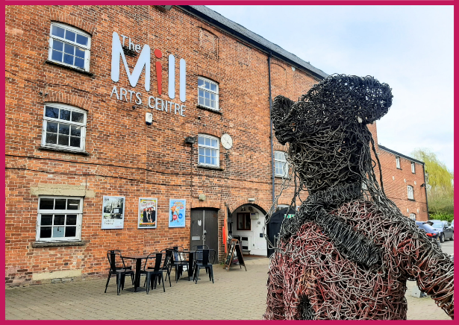The Mill is a small scale multi-art form venue with big ambitions. Situated in the North Oxfordshire market town of Banbury, it is the focus of cultural life as the only public arts and performance venue in the Cherwell District.

Our 237-seat theatre plays host to high quality professional theatre, dance, comedy and music productions, whilst supporting opportunities for local community arts organisations to work and perform in a professional space.

Our studio facilities offer a packed creative learning and participation programme focusing on both the visual and performing arts, covering everything from jewellery making to yoga, watercolour painting to creative writing and much more in between. In addition our café/bar and gallery area offers opportunities for local artists to exhibit and sell their work.

Increasingly we are working outside of our building and in partnership with a wide range of artists and organisations both in Banbury and Bicester to ensure that all in our communities can experience the evidential health and wellbeing benefits of seeing and taking part in professionally led creative and cultural activities.

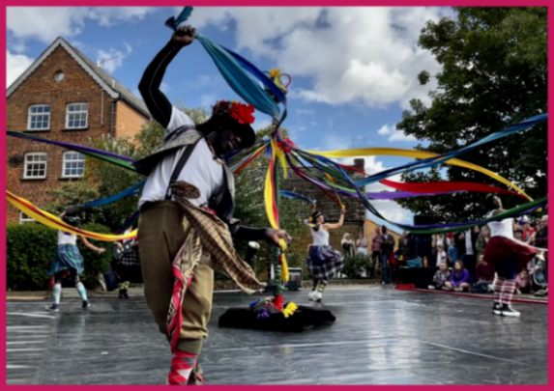Having joined Arts Council England’s National Portfolio in 2023, the successful candidate will join our ambitious team at a hugely exciting time.

This is an opportunity to play a key role to support the development of The Mill’s programme in line with Arts Council’s Let’s Create strategy and secure our place as the cultural heart of the region for generations to come.

[www.themillartscentre.co.uk](http://www.themillartscentre.co.uk)

**JOB DESCRIPTION**

**ROLE:** Programmer (Live)

**SALARY:** £24,135.90 (£30,169.88 FTE)

**HOURS:** 32 Hours per week

**RESPONSIBLE TO:** Creative Director

**CONTRACT:** Permanent

## **PURPOSE OF THE POST**

The Programmer will lead on the curation and administration of the live event programme and work closely with the Creative Director to support the strategic delivery of creative, financial and audience development objectives set out in The Mill’s Programme Framework and Audience Development Action Plan.

## **MAIN RESPONSIBILITIES**

* Working closely with the Creative Director, to lead on the curation of a programme of live events that meets the agreed creative, financial and audience development objectives as set out in the Programme Framework and annual plans and budgets.
* To research and identify companies whose work complements and extends the objectives of The Mill.
* To maintain and develop effective relationships with promoters, producers, artistic companies and industry contacts, acting as main point of contact to ensure that The Mill is viewed favourably and professionally at all times.
* To negotiate and agree financial deals and contractual terms with visiting companies and artists and ensure that all agreements are appropriately contracted, documented and approved in line with the scheme of delegation.
* To ensure effective communication and consultation with internal departments so that any logistical considerations arising from programming decisions are considered and agreed in advance.
* To work to agreed programming timelines and deadlines to support the production of regular what’s on guide, season launches and membership events.
* Preparation of final settlements post-event to ensure that all events are settled in accordance with the contractually agreed terms.
* Ensure effective record keeping and communication with visiting artistes to support the Finance Manager with compliance including the reconciliation of PRS (Performing Right Society), VAT and foreign entertainers tax as appropriate.
* Administer any amendments to the live programme as may be required from time to time including cancellations and rescheduled dates in line with the agreed terms.
* To clearly communicate The Mill Arts Centre’s requirements and expectations to visiting companies, as may be updated from time to time, and to support with the collation of all required information to include Health & Safety, Safeguarding, Insurance, Inclusion and environmental.
* Support with set up and cross-checking of new events on Spektrix (CRM) in line with agreed on-sale and membership schedules
* Liaise with other departments to communicate each visiting company’s requirements (e.g. riders, room layouts, merchandise) and effect introductions to relevant team members where required
* In conjunction with other members of the team, to go and see touring work in advance where possible in order to keep up to date with current trends, build networks and inform future programming decisions
* To work closely with the Community Engagement Officer and Sales & Marketing Manager to support consultation and evaluation of the programme, including attending focus group and networking events as required.
* To regularly attend events at The Mill to support continual audience development and engagement
* To maintain and nurture relationships with local community groups to support and encourage non-professional programming.
* To feed into and support the delivery of audience development initiatives set out in the Audience Development Action Plan, including those supporting Arts Council England funded activity outcomes.

## **GENERAL DUTIES**

* To represent The Mill positively and professionally at performances and events whether at The Mill or offsite
* Uphold all organisational values, policies and procedures, promoting those specifically relevant to the scope of the role such as Equality & Diversity, Access, GDPR, Safeguarding and Health & Safety
* Undertake training as deemed necessary to support ongoing effective performance in the role

This job description is a guide to the nature of the work required. It is not wholly comprehensive or restrictive. This job description can be reviewed at any time.

## **PERSON SPECIFICATION**

|  |  |
| --- | --- |
| **ESSENTIAL** | **DESIRABLE** |
|  |  |
| A genuine commitment to broadening access to the arts for all | Formal theatre and/or arts qualification |
| A proven track record in producing and/or programming events within an arts-based organisation | Previous experience of the Spektrix CRM system |
| Excellent verbal and written communication skills | Established network of contacts within the small to mid-scale UK touring circuit |
| Methodical approach with high standards of attention to detail and administration skills |  |
| Evident commercial acumen, numeracy and effective negotiation skills |  |
| Excellent time and workload management with the ability to work to tight deadlines |  |
| Analytical approach with demonstrable experience of using data to inform decision making |  |
| Confident and professional manner |  |
| Collaborative approach to team working with a positive and forward-thinking attitude to the wellbeing of others |  |
| Evidence of ability to work effectively with a wide range of people and organisations to build positive relationships |  |
| Self-motivated with the ability to work unsupervised |  |

## **HOW TO APPLY**

Please apply by sending the following to Emma Hiorns, Creative Director ([emma.hiorns@themillartscentre.co.uk](mailto:emma.hiorns@themillartscentre.co.uk)) by midday on Tuesday 26th August 2025:

* a completed [application form](https://www.themillartscentre.co.uk/wp-content/uploads/2023/02/MACT-Application-Form.doc)
* a short cover letter explaining your interest in the position

If you have any questions or require assistance, please contact [emma.hiorns@themillartscentre.co.uk](mailto:emma.hiorns@themillartscentre.co.uk).

Interviews for shortlisted candidates are scheduled to take place on Thursday 4th & Monday 8th September 2025.

If this pack or the application form is not accessible for you, please contact us to make alternative arrangements.