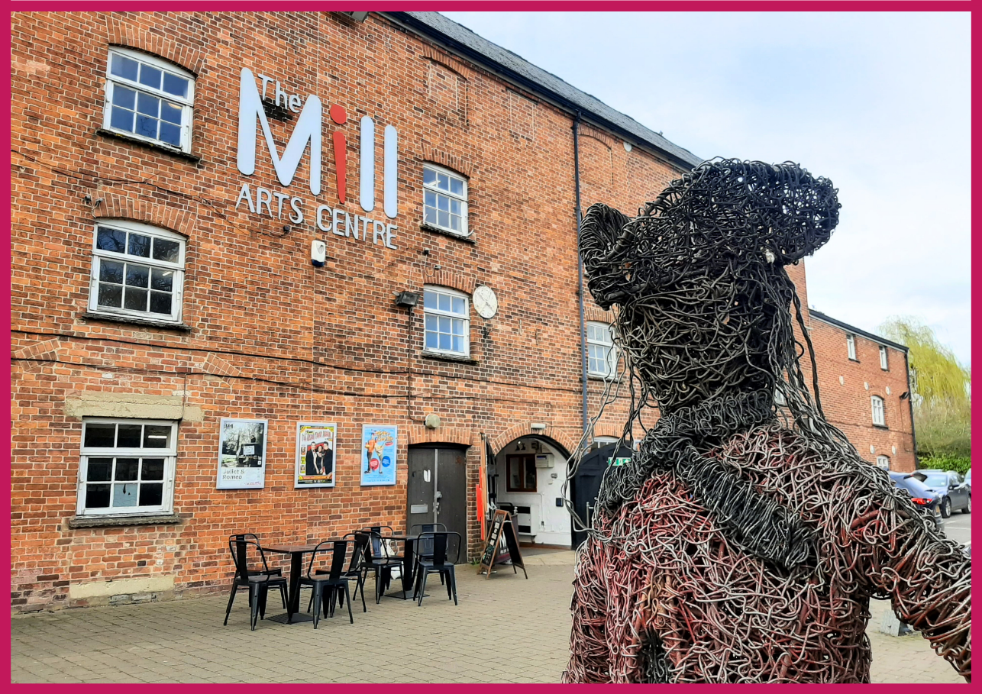
Work Experience Pack
HELLO & WELCOME
Thank you for your interest in our 2026 Work Experience Programme. Our programme offers 14–18-year-olds a hands-on experience that will broaden understanding of the arts and cultural sector and provide valuable insights into the multifaceted operations of The Mill Arts Centre.

Dates and time of each placement will be arranged and agreed between the Creative Learning Officer and the successful applicant.

This pack contains:
- Information about The Mill
- Information about our Work Experience programme
- Health and Safety Information
- How to apply to take part in the Mill’s 2026 Work Experience programme.

If you would like this information in a different format, please contact
laura.walker@themillartscentre.co.uk

ABOUT THE MILL

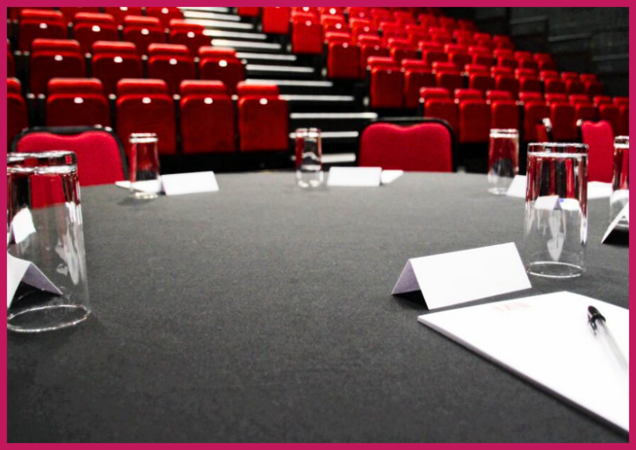
The Mill is a small multi-art form venue with big ambitions. Situated in the North Oxfordshire market town of Banbury, it is the focus of cultural life as the only public arts and performance venue in the Cherwell District.

Our 237-seat theatre plays host to theatre, dance, comedy, and music events which run alongside a packed creative learning and participation programme with a focus on both visual and performing arts.

Increasingly we are working outside of our building and in partnership with a wide range of organisations in Banbury and Bicester to ensure that all in our communities can experience the benefit of seeing and taking part in professionally led creative and cultural activities.

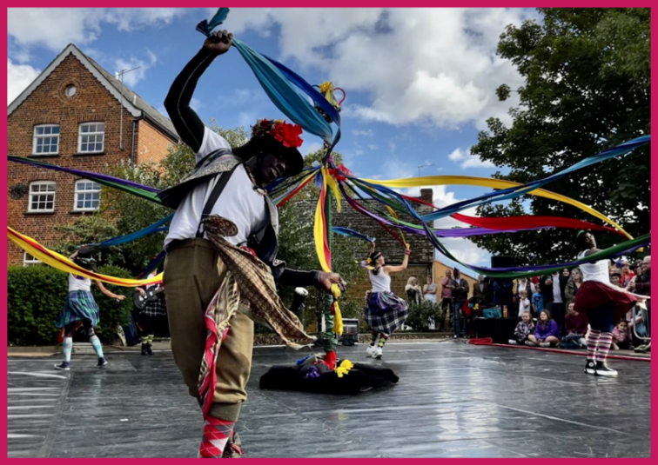
Having recently been successful in our application to become a National Portfolio Organisation for Arts Council England, the successful candidate will join our ambitious team at a hugely exciting time. This is an opportunity to play a key role to support the development of The Mill in line with Arts Council’s Let’s Create strategy and secure its place as the cultural heart of the region for generations to come.

OUR VISION & VALUES

The Mill aims to be the cultural heart of Banbury and beyond. Proudly celebrating a diverse creative programme of high-quality arts experiences; telling stories that encourage everyone in our communities to learn and take part; to have fun and be inspired.

We want to be an exemplar, vibrant, indispensable Arts Centre of which Banbury is rightly proud; relevant to the whole community through a diverse programme which celebrates both taking part in and seeing first class arts and entertainment experiences.

We are much more than just a building, we will work throughout the region to support artists to create and present the highest quality arts experiences.

Our vision is to:
- Nurturing your creativity
Providing opportunities to be creative at every stage in life
- Your venue for arts and entertainment
Banbury’s creative hub and the home for live performance
- Celebrating your stories
Exploring what connects us through culture
- Your home for dance
Supporting a thriving community of dance artists and audiences to shine a vibrant light on Banbury
- Bringing creativity and culture to you
Reaching new audiences in unexpected places
Our core values lead the organisation throughout each department, they are:
Trust
- It’s never about us. Our plans and programme are driven by what our communities want and need.
- Trusting artists to do what they do best and valuing their work
- Consistently reliable and high quality; building trust with our audiences
- Taking our responsibilities seriously: to our environment, our people and communities
For all
- We will nurture a tolerant, respectful and open-minded culture of acceptance where everyone can belong
- We respect choice – people with differing views and experiences are equally welcome and valued
- Inclusivity is at the heart of what we do: exploring ways to identify & remove potential barriers to access
Aspirational
- Dreaming big: Ambitious in the scale of our vision for the communities we serve
- Raising aspirations amongst our audiences through showcasing a world of opportunity and experiences through our programme
- Nimble in identifying opportunities to bring our vision to life
Vibrant
- Bringing colour, creativity and life to the places where we live, work and play
- Whilst at times we may seek to challenge or provoke, happiness and joy are never far from what we do.
- Passionate advocates for the role of creativity and culture to transform communities

To achieve our aims, we offer three strands of work:
- Live events and film screenings including theatre, dance, music and comedy.
- Participatory workshops, events and experiences including performing arts, visual arts and craft and holistic wellbeing.
- Visual art exhibitions.

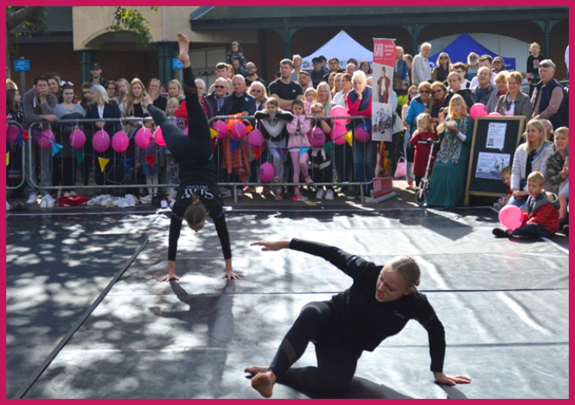
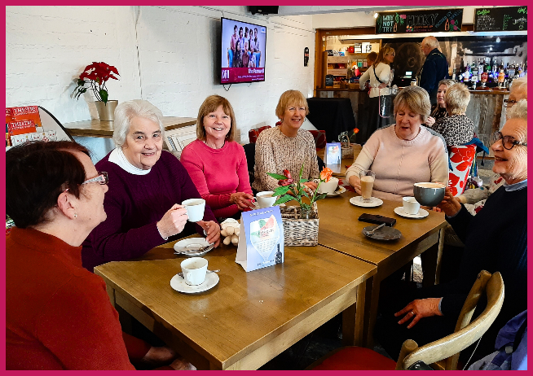

ABOUT THE 2026 WORK EXPERIENCE PROGRAMME

Post: Work Experience Student
Reporting to: Creative Learning Officer
Salary: This is an unsalaried opportunity.
Place of work: The Mill Arts Centre, with the opportunity to work across our off-site programme in other locations (please note this is not a requirement)
Hours of Work: Dates and time of each placement will be arranged and agreed between the Creative Learning Officer and the successful applicant. Some activities may take place during evenings and weekends due to the nature of the business.

The Mill Arts Centre can offer a diverse range of activities throughout the work experience programme involving most departments within the organisation. Some activities may take place during evenings and weekends due to the nature of the business. Timetables will be created to fit in with the students work experience structure.

The main activities will take place with the following departments:

- Programme & Marketing
- Operations / Front of House
- Technical
- Creative Learning
- Community Engagement
- Art Centre Administration

Activities might include:

- Exhibition hanging
- Creating a marketing plan
- Distributing flyers and posters around town
- Taking minutes during meetings
- Assisting with the Technical team
- Setting up room hires and functions
- Hospitality & Box Office
- Ushering for a show
- Creating social media posts

HEALTH & SAFETY
All work experience students will be inducted to The Mill’s health and safety policies and procedures. All work experience students will be expected to follow all health and safety procedures and any actions demonstrated by our health and safety committee.

The Mill Arts Centre will be able to provide DBS numbers for our staff and information about our Designated Safeguarding Leaders.

Due to the historic nature of the building, we regrettably are unable to facilitate wheelchair users above the ground floor.

HOW TO APPLY
Please apply by sending the following to Laura Walker (laura.walker@themillartscentre.co.uk) by Friday 20th February at 5pm.

- a completed application form

If you have any questions or require assistance, please contact laura.walker@themillartscentre.co.uk.

Good luck!

